“Starbucks Stock Analysis Report”

*Empowering Financial Decisions with SQL: A Deep Dive into Stock Performance and Corporate Actions*



# 1. Overview

This project leverages SQL to explore and analyze Starbucks’ historical stock performance and corporate actions. The goal is to extract insights that help investors and analysts understand trading behavior, dividend patterns, and market volatility. The insights derived from this analysis can support better financial forecasting, risk evaluation, and investment planning.

# (Power Query + SQL Integrated project)

# _MOHAMMED AMEEN PA_

## 2. Problem Statement

Modern financial analysts and investors have access to vast volumes of trading data but often struggle to extract actionable insights. Without structured data models and SQL-driven analytics, understanding long-term patterns such as dividend growth, market volatility, and trading behavior becomes difficult.

**Key Challenges:**

* Unstructured and denormalized raw datasets.
* Difficulty identifying high-activity periods or performance trends.
* Limited visibility into dividend and split events over time.

**Objective:**

* Normalize and structure the data into separate analytical tables.
* Use SQL queries to derive insights on price trends, trading volumes, and dividend patterns.
* Present key financial insights for better investment decisions.

# 3. Data Description

The dataset consists of Starbucks’ daily stock trading records and corporate financial actions (dividends and stock splits).

|  |  |  |
| --- | --- | --- |
| **Table** | **Columns** | **Description** |
| stock_history | trade_date, open, high, low, close, volume | Records daily price and trading data |
| stock_actions | action_date, dividends, stock_splits | Records corporate financial events |

**ERD DIAGRAM:**

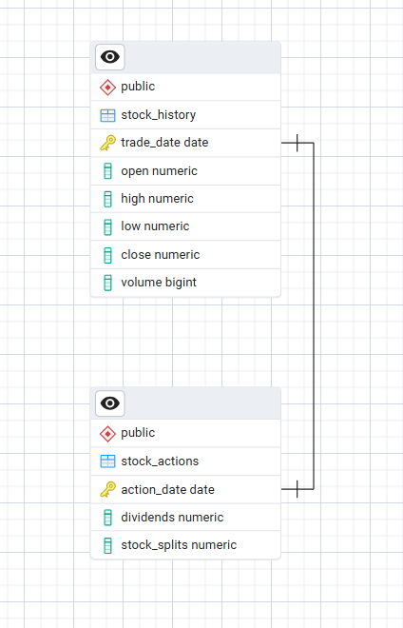

**INSIGHT:**

This diagram shows that my tables relationship type follows one to one relationship.

Here there are 2 tables stock_history and stock_action these 2 tables are connected with the primary keys trade date and action date .

# 4. Key Analytical Queries and Insights

## 1. Highest Stock Price

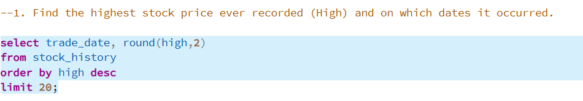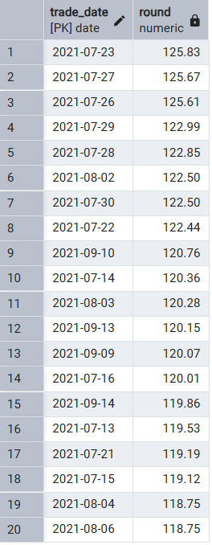

### **Insight:**

*Identifies the peak trading value and date — helps understand historical highs and market performance benchmarks.*

## 2. Average Closing Price per Year

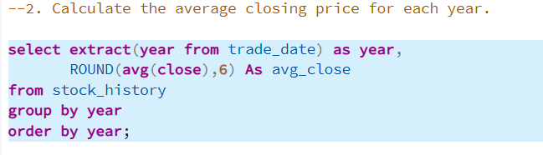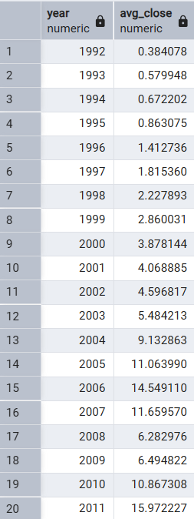

### **Insight:**

*Reveals long-term trends and annual performance changes — supports investment timing decisions.*

## 3. Highest Daily Volatility

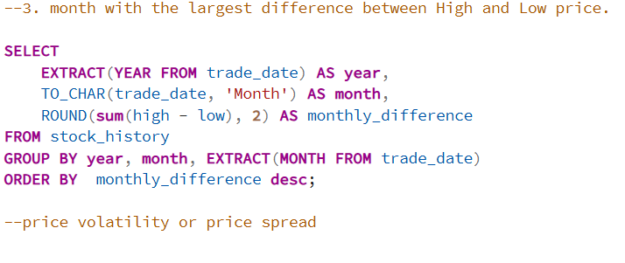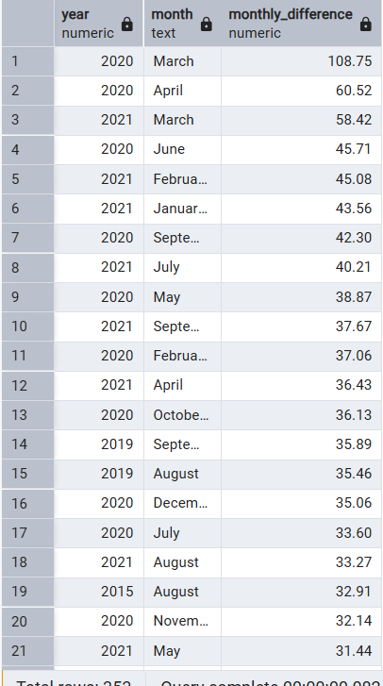

### **Insight:**

*Shows which trading day experienced the largest market fluctuation — useful for risk assessment.*

## 4. Average Monthly Trading Volume

## 

### **Insight:**

*Indicates investor engagement and liquidity levels over time.*

## 5. Top Trading Volume months

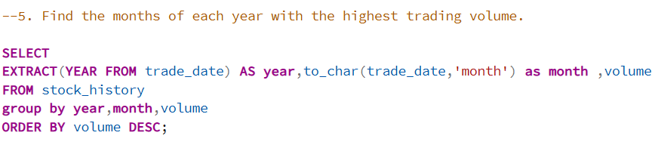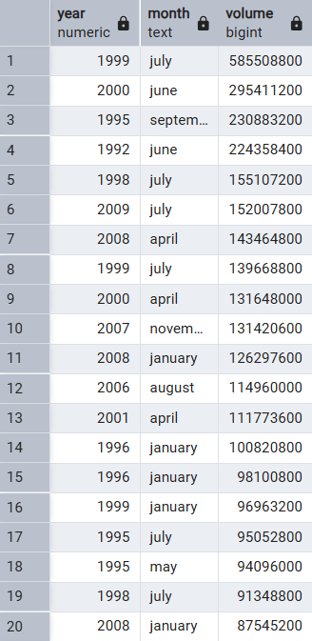

### **Insight:**

*Highlights the most active trading days — often aligned with major news or earnings announcements.*

## 6. Dividend Payment History

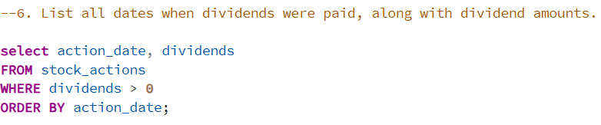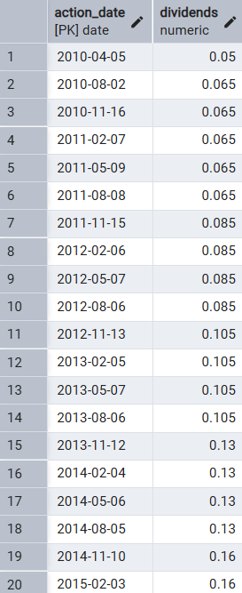

### **Insight:**

*Shows Starbucks’ payout trends and helps assess shareholder return consistency.*

## 7. Stock Split Count

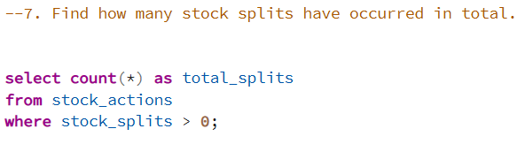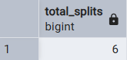

### **Insight:**

*Indicates how often the company has adjusted share structure — a signal of market confidence.*

## 8. Yearly Dividend vs. Average Closing Price

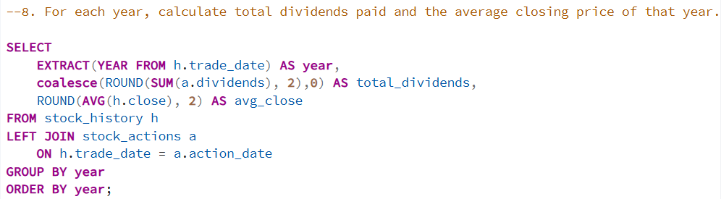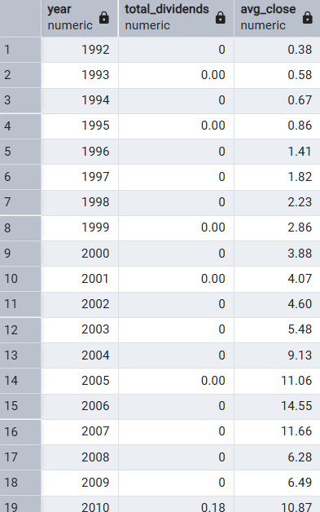

### **Insight:**

*Shows relationship between dividends and stock price trends — useful for assessing value growth.*

## 9. Rank Top Trading Days by Volume (can be changeable as per the year)

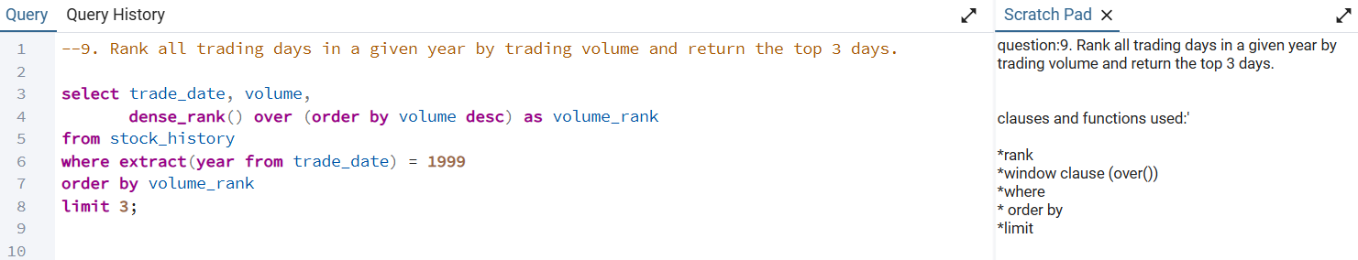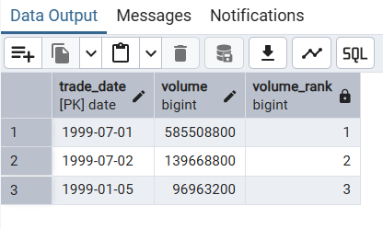

### **Insight:**

*Identifies key high-activity days — valuable for short-term traders and market analysts.*

Market Maturity:

As a company grows, the stock often stabilizes — traders lose interest, and only long-term investors remain.

Share Buybacks or Splits:

If the company performed a stock split or buyback, the number of shares available for trading can change, reducing volume.

## 10. price changes on dividend days

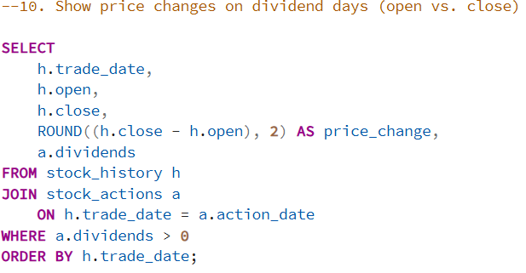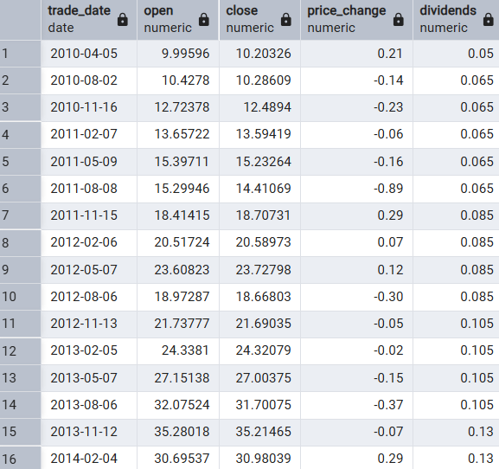

### **Insight:**

*Smooths price fluctuations, and are able to understand that the price difference on dividend dates.*

# 5. Insights and Conclusions

The SQL-based exploration of Starbucks’ stock data provides the following insights: Consistent growth patterns with stable long-term averages. - Noticeable volume surges align with corporate announcements and dividend dates. - Regular dividend payouts reflect steady company performance. - Volatility analysis identifies critical risk periods for investors. - Data normalization ensures reliable and scalable financial reporting. In conclusion, this analysis demonstrates how structured SQL queries can transform raw stock data into strategic business intelligence. The findings can guide investors, analysts, and management teams toward better forecasting, performance tracking, and investment decisions.